Section 1: Case Summary

Scenario Title: | Suspected COVID-19 (Ambulatory)
Keywords: | PPE, traveler, infection control, COVID-19
Brief Description of Case: | A 38 year old male has returned from a business trip in Asia last week. Over the last 48h, he has developed fever, rigors, myalgias as well as nausea, vomiting and upper respiratory symptoms. He initially was trying to ride it out at home, but is feeling increasingly short of breath and fatigued. He has now presented to your ambulatory care clinic.  The goal of the case will be to recognize the need to isolate the patient and use appropriate PPE, while assessing and managing his viral illness. The case starts in the triage office, moves to a room with MD assessment and may also involve handover to EMS for transfer.

Goals and Objectives
Educational Goal: | Examine the processes around identification of infectious presentations requiring isolation and advanced infection control procedures, as well as use of PPE
Objectives:  (Medical and CRM) | - Early recognition of infectious symptoms in a returning traveler and the need for infection control procedures  - Appropriate use of PPE, including N95 masks and donning and doffing procedures, as detailed in local guidelines  - Use of a negative pressure room or alternative when available
EPAs Assessed: | N/A

Learners, Setting and Personnel
Target Learners: | ☐ Junior Learners |  | ☐ Senior Learners |  |  | ☒ Staff
 | ☒ Physicians | ☒ Nurses |  | ☐ RTs | ☒ Inter-professional
 | ☒ Other Learners:
Location: | ☐ Sim Lab |  | ☒ In Situ |  |  | ☐ Other:
Recommended Number of Facilitators: | Instructors: facilitators to observe
 | Confederates: None
 | Sim Techs: None

Scenario Development
Date of Development: | February 10th, 2020
Scenario Developer(s): | Dr. Alex Chorley, MD
Affiliations/Institutions(s): | McMaster University
Contact E-mail: | alexander.chorley@medportal.ca
Last Revision Date:
Revised By:
Version Number: | 1

Section 2A: Initial Patient Information

- Patient Chart
Patient Name: Tony Stark |  |  |  | Age: 38 | Gender: M | Weight: 70kg
Presenting complaint: Shortness of Breath
Temp: 39.1 | HR: 120 | BP: 130/75 |  | RR: 25 | O₂Sat: 89% | FiO₂: R/A
Cap glucose: 5.2 |  |  |  | GCS: 15
Triage note:
The patient has returned from a business trip in Wuhan, China last week. Over the last 48h, he has developed fever, rigors, myalgias as well as nausea, vomiting and upper respiratory symptoms. He initially was trying to ride it out at home, but is feeling increasingly short of breath and fatigued. Hasn’t taken any antipyretics today. No diarrhea.

Allergies: Sulfa
Past Medical History:  None |  |  | Current Medications:  None

Section 2B: Extra Patient Information

A. Further History
Include any relevant history not included in triage note above. What information will only be given to learners if they ask? Who will provide this information (mannequin’s voice, confederate, SP, etc.)?

N/A
B. Physical Exam
List any pertinent positive and negative findings
Cardio: Normal HS | Neuro: Alert and oriented, no focal deficits
Resp: Tachypneic, mild WOB, crackles to RLL | Head & Neck: Normal but congested
Abdo: Soft non tender | MSK/skin: no rash, cap refill <2s
Other:

Section 3: Technical Requirements/Room Vision

A. Patient
☐ Mannequin (specify type and whether infant/child/adult)
☒ Standardized Patient
☐ Task Trainer
☐ Hybrid
B. Special Equipment Required
PPE: N95 Masks, gowns, gloves, face shield. Negative pressure room if available.

C. Required Medications
None.

D. Moulage
None.

E. Monitors at Case Onset
☐ Patient on monitor with vitals displayed
☒ Patient not yet on monitor
F. Patient Reactions and Exam
Include any relevant physical exam findings that require mannequin programming or cues from patient
(e.g. – abnormal breath sounds, moaning when RUQ palpated, etc.) May be helpful to frame in ABCDE format.

As above

Section 4: Confederates and Standardized Patients

Confederate and Standardized Patient Roles and Scripts
Role | Description of role, expected behavior, and key moments to intervene/prompt learners. Include any script required (including conveying patient information if patient is unable)
Patient | You returned 5 days ago from a 1 week trip to China, including Wuhan. You felt fine on the plane and for the first few days, then developed cough, runny nose and sore throat. You went on to develop fever, chills, shakes and muscle aches. There have been several episodes of nausea and vomiting but no diarrhea. There hasn’t been any blood in your vomit. You feel like it’s been increasingly hard to breathe and you are breathing more quickly than usual. The cough is bringing up some green phlegm.

Section 5: Scenario Progression

Scenario States, Modifiers and Triggers
Patient State/Vitals | Patient Status | Learner Actions, Modifiers & Triggers to Move to Next State |  | Facilitator Notes
1. Triage Office  Rhythm: Sinus Tach  HR: 120  BP: 130/75  RR: 25  O₂SAT: 89%  T: 39.1ºC  GCS: 15 | Patient has mild tachypnea and work of breathing | Expected Learner Actions  Triage patient (brief Hx&Px)  Respiratory illness screening  Perform vitals  Have patient wear a mask  Notify charge nurse of need for isolation | Modifiers  Changes to patient condition based on learner action  Triggers  For progression to next state  Patient moved to room 2. Isolation Room
2. Isolation Room  Rhythm: Sinus Tach  HR: 120  BP: 130/75  RR: 25  O₂SAT: 89%  T: 39.1ºC  GCS: 15 | Unchanged | Expected Learner Actions  Move patient to negative pressure room or alternative  Don appropriate PPE (Per local protocols)  Brief History & Physical  Notify MD, contact Infection Control  Apply O₂  Doff PPE on exit of room | Modifiers  O₂ applied SpO2 to 95%  Triggers  MD arrival 3. MD Assessment
3. MD Assessment  Rhythm: Sinus Tach  HR: 120  BP: 130/75  RR: 25  O₂SAT: 89%  T: 39.1ºC  GCS: 15 | Unchanged | Expected Learner Actions  MD dons appropriate PPE  History and Physical  CXR (Portable)  Bloodwork (incl Cultures)  IV Fluids  Antibiotics (Ceftriaxone + Azithro vs Fluroquinolone)  Contact ID re: swabs/work up | Modifiers  IV Fluid bolus HR to 105  O₂ applied SpO2 to 95%  Triggers  ID/Infection control contacted End Case  -OR-  EMS contacted 4. Transport
4. Transport (optional)  Rhythm: Sinus Tach  HR: 105  BP: 130/75  RR: 25  O₂SAT: 95% (NP)  T: 39.1ºC  GCS: 15 |  | Expected Learner Actions  Pt PPE for transport  PPE for EMS  Clinical handover to EMS  Arrange appropriate cleaning of room and equipment | Modifiers  -  -  -  Triggers  - Handover to EMS Team End Case

Appendix A: Laboratory Results

None given during scenario

Appendix B: ECGs, X-rays, Ultrasounds and Pictures

Paste in any auxiliary files required for running the session. Don’t forget to include their source so you can find them later!
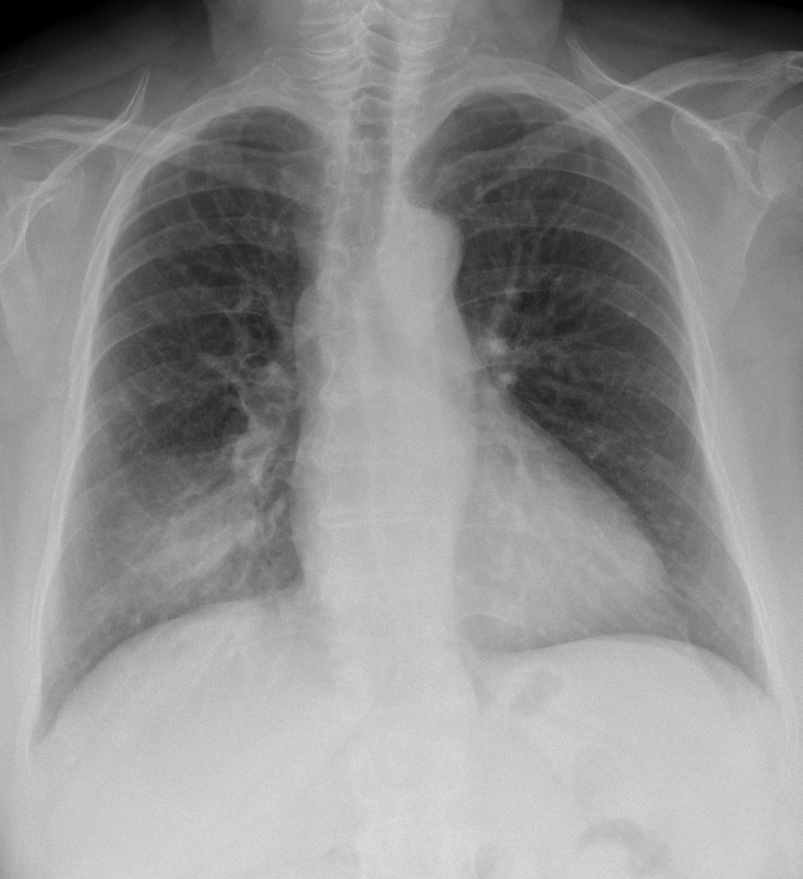
Case courtesy of Dr Henry Knipe, Radiopaedia.org, rID: 31352

Appendix C: Facilitator Cheat Sheet & Debriefing Tips

Include key errors to watch for and common challenges with the case. List issues expected to be part of the debriefing discussion. Supplemental information regarding any relevant pathophysiology, guidelines, or management information that may be reviewed during debriefing should be provided for facilitators to have as a reference.

In Situ Simulation for Emerging Diseases

In situ simulation is a team-based training technique conducted in actual patient care areas using equipment and supplies from that area with people from the care team. In situ simulation has been used successfully to identify latent safety threats, including fixable problems with teamwork, systems issues and adherence to guidelines.

In the case of COVID-19 and other novel infectious diseases, guidelines are distributed that often present a challenge for frontline staff because they are both different from usual procedures and rapidly evolving. In situ simulation offers an opportunity to practice using these guidelines and identify issues that are preventing staff from adhering to these guidelines.

This case should be run with local guidelines in mind and may include a diverse group of stakeholders (front-line workers, infection prevention and control, infectious disease specialists and administrators).

Some Questions to Explore during the Debrief

- How do we use PPE to keep providers safe? How do we effectively use the PPE?
- How do we keep other patients safe?
- What space will we use to care for the patient? How is this cleaned?
- What are some high risk activities to be aware of?
- What are the policies on bringing equipment in and out of the room?
- Who needs to be notified/consulted in this case?
- How do we coordinate transfer/handover to other services and providers?
- How do we find the most up-to-date policies and procedures?

References

1. https://www.who.int/emergencies/diseases/novel-coronavirus-2019
2. https://www.cdc.gov/coronavirus/index.html
3. https://ipac-canada.org/coronavirus-resources.php

